
Name: Abdul Samad
Program: BSSE Group A
Semester: 5th
Date: October 1, 2026
*-----------------------------------------------*

Lab Task 4.1
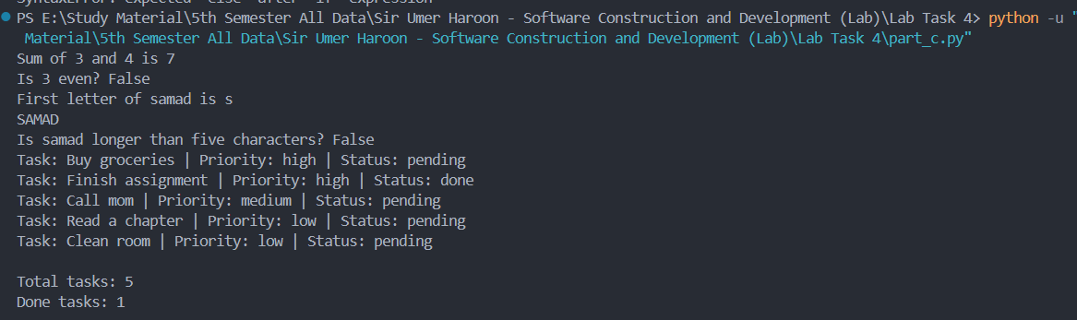

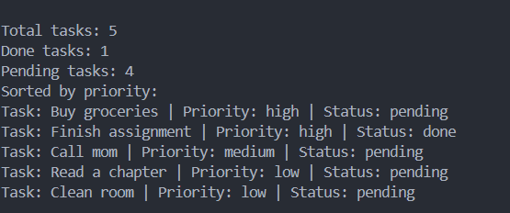

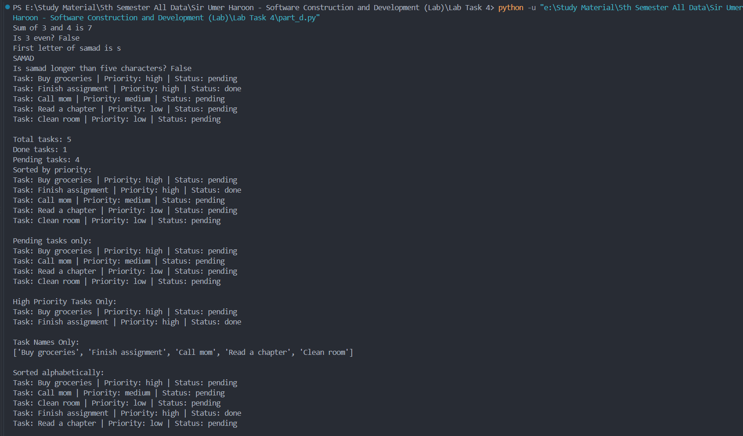

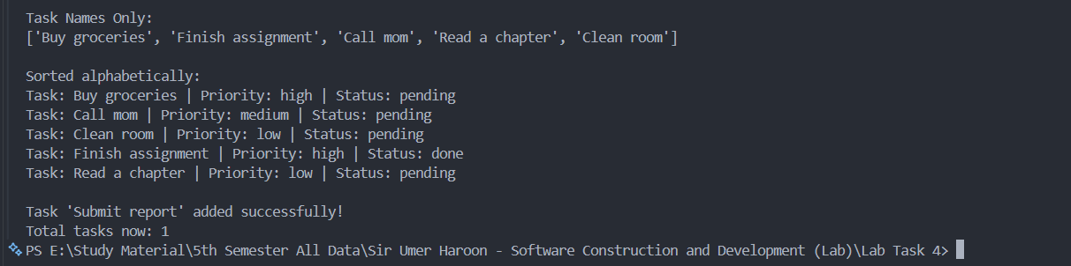

Part D: Reflection Answers

- Why is bad_add_task hard to test?

Because it does way too many things in a single block. It checks the inputs, creates the task dictionary, appends it to the list, and prints messages to the screen all at once. If I want to write an automated test to check if a task actually got added or if the validation worked, I can't just check a simple return value or list state easily because the function forces print statements out to the terminal at the same time.

- Why is it hard to reuse?

Because it has print() statements hardcoded right inside it. If I want to use this same function later in a GUI app, a web project, or a script where I don't want terminal output, it will still keep printing text every single time it runs. Since the list logic and the visual printing are stuck together, you can't use the function anywhere else without bringing along the annoying prints.

- Which single responsibility should be extracted first?

Input validation (is_valid_priority and is_valid_status). Checking whether the user entered a valid priority or status is a completely separate job that needs to happen first, before you even try to create a task dictionary or modify the list.

*-----------------------------------------------*

The End

